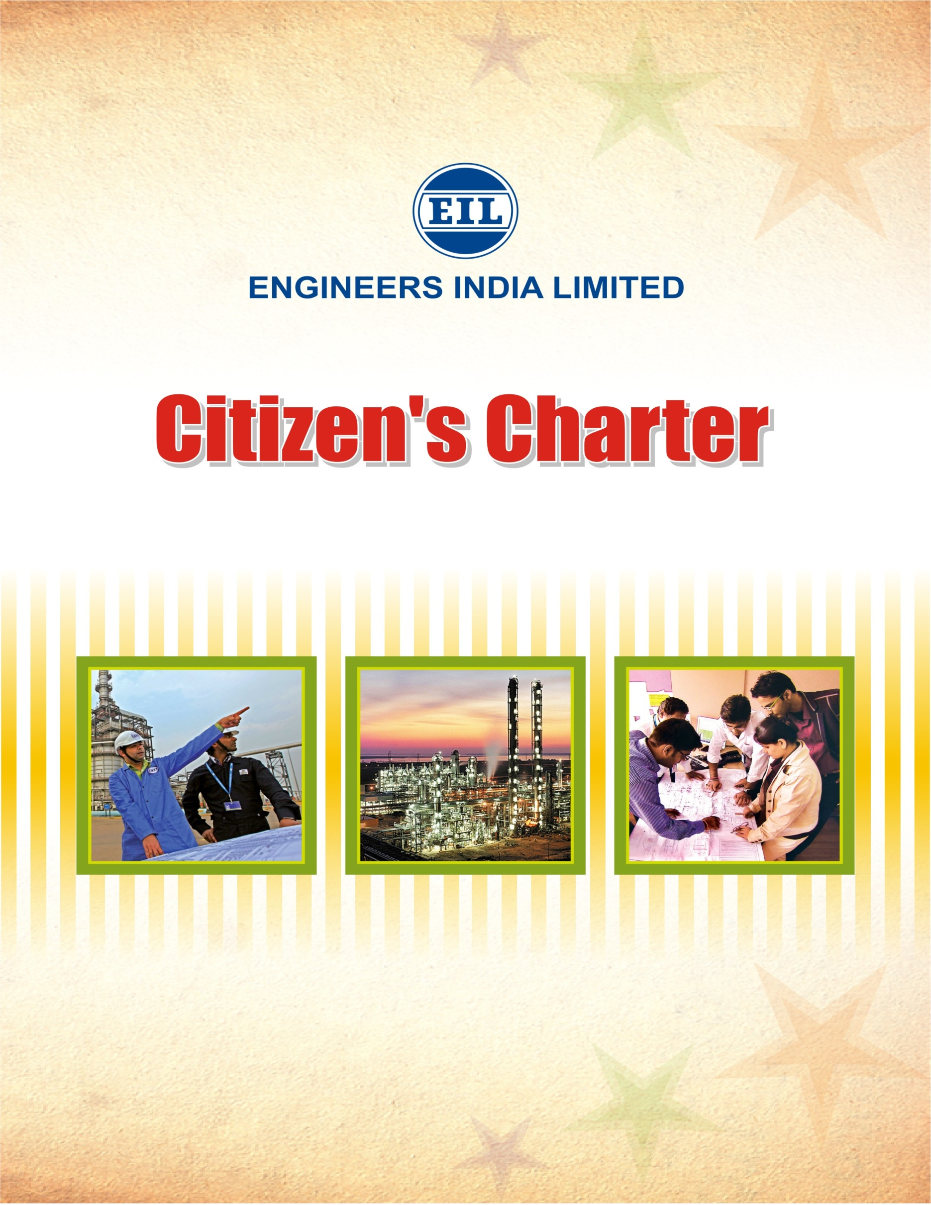

May, 2014

The main objective of the Citizen's Charter is to inform the public about the mandate of the Company, how one can get in touch with its officials, what to expect by way of services and how to seek a remedy if something goes wrong.

The Citizen’s Charter does not, by itself, create new legal rights, but it surely helps in enforcing existing rights.

Index

SI.No | Subject | Page No.
1. | Vision, Mission and Core Values  of the Company | 4
2. | Activities | 4
3. | Services Offered | 6
4. | Major Clients | 8
5. | MoU With Government | 9
6. | Awards & Accolades | 9
7. | Five Years' Performance at a Glance | 10
8. | Grievance Redressal System | 10

1.0 MISSION AND OBJECTIVES OF THE COMPANY

1.1 VISION
To be a world-class globally competitive EPC and total solutions Consultancy Organisation.

1.2 MISSION
- Achieve 'Customer Delight' through innovative, cost effective and value added consulting and EPC services.
- To maximize creation of wealth, value and satisfaction for stakeholders with high standards of business ethics and aligned with national policies.

1.3 CORE VALUES
  - Benchmark to learn from superior role models.
  - Nurture the essence of Customer Relationship and Bonding.
  - Foster Innovation with emphasis on value addition.
  - Integrity and Trust as fundamental to functioning.
  - Thrive upon constant Knowledge updation as a Learning organisation.
  - Passion in pursuit of excellence.
  - Quality as a way of life.
  - Collaboration in synergy through cross-functional Team efforts.
  - Sense of ownership in what we do.

2.0 ACTIVITIES
2.1 Overview
Engineers India Ltd (EIL) is one of the leading design and engineering organizations in South Asia. Established in 1965, EIL provides engineering consultancy and EPC services principally focused on the oil & gas and petrochemical industries. The Company has also diversified into sectors like Infrastructure, Water and Waste Management, Solar & Nuclear Power and Fertilizers to leverage its strong technical competencies and track record.

Today, EIL is the only ‘Total Solution’ engineering consultancy company in India providing design, engineering, procurement, construction and integrated project management services from ‘Concept to Commissioning’ with highest quality and safety standards. It also provides specialist services such as heat and mass transfer equipment design, environmental engineering, specialist materials & maintenance and plant operations & safety services.

With corporate office in New Delhi, EIL also operates from its regional offices at Kolkata, Chennai and Vadodara, branch office at Mumbai and has inspection offices at all major manufacturing locations of the country. The company’s overseas presence is marked by an engineering office in Abu Dhabi, which caters to the business needs in UAE/Middle-East region and the South-East Asia market is served by its Kuala Lumpur office. Additionally, there are offices in London, Milan, Shanghai and Caracas (Venezuela) to coordinate the activities of international procurement and marketing.

Over the last four and a half decades, EIL has played a significant role in shaping the hydrocarbon industry and the related manufacturing sector in the country. The Company has its footprints in 19 of the 22 operating refineries in the country. In the hydrocarbon consultancy, EIL’s endeavors have resulted in achieving 95% self sufficiency as compared to only 5% at the time of its inception. EIL has also been instrumental in development of indigenous manufacturing capabilities for hydrocarbon industry resulting in reduction of machinery imports to around 25-35% of the plant cost as compared to around 80% in early 80s.

2.2 Track Record

EIL has an impressive record of executing over 5000 assignments valued over $200 Billion. EIL’s enviable project portfolio consists of:

- 59 refinery projects, including 10 Greenfield refineries
- 7 mega petrochemical complexes
- 8 Fertilizer Plants
- 36 oil and gas processing projects
- 209 offshore platforms projects
- 46 pipeline projects of more than 12000 km in India and abroad
- 28 Mining & Metallurgy Projects
- 13 ports and storage & terminals projects
- 29 infrastructure projects including airports, highways, flyovers, bridges, water and sewer management, as well as energy-efficient” intelligent” buildings.
- 17 turnkey projects.

Some milestone projects executed by EIL include world’s longest deck (136 m) on single jacket for SHG Platform of ONGC, Jamnagar-Loni Pipeline of GAIL, one of the largest LPG pipelines in the world and recently completed 9 MMTPA Guru Gobind Singh Refinery of HMEL, the 10th Grassroot refinery designed and engineered by EIL which has also set various industry benchmarks in terms of project execution.

3.0 SERVICES OFFERED
3.1 Spectrum of Services Offered - From Concept to Commissioning

PROCESS DESIGN SERVICES
- Conceptual designs and feasibility reports
- Basic design packages for
- Open art process units for Gas-Processing and Refineries
- Integrated Utilities and Offsite facilities
- Offers a portfolio of more than 30 process technologies for application in Oil and Gas Processing sector
- Residual basic engineering for licensed process units
- Yield and energy optimization and capacity augmentation services in process plants

ENGINEERING SERVICES
- Expertise ranges for all engineering services such as Piping, Mechanical, Electrical, Control Systems, Civil, Structural and Architectural, including Advanced Engineering Analysis
- Specialised services for
- Heat and Mass Transfer
- Environment Engineering
- Materials and Maintenance services

PROCUREMENT SERVICES
- Comprehensive procurement services such as strategic sourcing, materials management, contracts management, purchase, expediting, inspection services and logistics
CONSTRUCTION MANAGEMENT SERVICES
- Comprehensive services at site including warehouse management, quality control and assurance, health safety and environment (HSE), progress monitoring and scheduling
- Undertakes total site responsibility from survey and soil investigation to mechanical completion of project
COMMISSIONING SERVICES
- Services include audit of plant readiness, start-up, commissioning and conducting performance guarantee tests
- Includes pre-commissioning and commissioning assistance for projects
- Safety Audit, Hazard and Operability Studies (HAZOP), Risk and Consequence Analysis Services
PROJECT MANAGEMENT SERVICES
- Integrated project management services with focus on cost, quality and schedule
- Services include developing schedules, cost forecasts, progress tracking and reporting, and the integration of the engineering, procurement, logistics, construction and commissioning works
CERTIFICATION SERVICES
- Certification, re-certification and Third Party Inspection (TPI) services through EIL’s subsidiary company - Certification Engineers International Ltd.

3.2 Modes of Contracting
EPC - Engineering, Procurement & Construction
Contracts under which EIL is responsible for the entire project as a turnkey contractor. EPC contracts fall into two broad categories:
- Lump-sum Turnkey (LSTK) contracts
- Open Book Estimate (OBE) contracts (form of cost reimbursable contract) with a provision for conversion to LSTK for a project. Benefits under OBE contracts primarily relate to ensuring control over the time and expenses for a project and greater certainty of outcome.

EPCM - Engineering, Procurement and Construction Management
Contracts under which EIL provides services related to process engineering, detail engineering, procurement, construction supervision through co-ordination of various suppliers & contractors and commissioning & pre-commissioning assistance
FEED - Front End Engineering & Design
Upstream process design, residual basic design and front-end basic engineering for complete definition of scope for selection of EPC contractor
PMC - Project Management Consultancy
Contracts under which EIL provides comprehensive project management services for the implementation of a project through turnkey contractors ensuring design, quality and schedule

4.0 MAJOR CLIENTS
EIL provides complete range of services needed to conceptualize, design, engineer and construct projects to meet the specific requirements of its clients. EIL’s clients include companies in the Public and Private sectors both in domestic and international markets.

The major clients in the domestic segment include
- Bharat Oman Refineries Ltd,
- Bharat Petroleum Corpn. Ltd,
- Bongaigaon Refinery & Petrochemicals Ltd,
- Brahmaputra Cracker & Polymers Ltd,
- Chennai Petroleum Corpn Ltd,
- Delhi Jal Board,
- Essar Oil Ltd,
- GAIL (India) Ltd,
- HPCL - Mittal Energy Ltd,
- ISPRL Ltd.
- Gujarat State Petroleum Corpn. Ltd,
- Haldia Petrochemicals Ltd,
- Hindalco Industries Ltd,
- Indian Oil Corporation Ltd,
- Kochi Refineries Ltd,
- Mangalore Refinery & Petrochemicals Ltd,
- National Aluminium Co. Ltd.
- Numaligarh Refineries Ltd,
- Oil and Natural Gas Corporation Ltd, and
- OPaL (ONGC Petro additions Limited).

Major overseas clients include
- Abu Dhabi Gas Industries Ltd. (GASCO),
- Abu Dhabi Oil Refining Co. (Takreer),
- Abu Dhabi, ADCO, Abu Dhabi,
- Bahrain Petroleum Co. (BAPCO), Bahrain,
- BANAGAS, Bahrain,
- SO Octane Company, Dubai,
- KNPC, Kuwait, KPRL, Kenya,
- NAFTEC Spa, Algeria,
- NPCC, Abu Dhabi,
- ORPC, Oman,
- Petro Venezolana S.A., Venezuela,
- QAPCO, Qatar,
- Qatar Fuel Company (WOQOD),
- Qatar Petroleum, Ras Gas, Qatar,
- Samsung Heavy Industries Ltd., Korea,
- Sohar Refining Company, Oman,
- SONATRACH, Algeria,
- Sudapet, Sudan,
- Technimont S.P.A., Italy and
- WNPOC, Sudan.

5.0 MOU with GOVERERNMENT
EIL has secured Excellent rating in the MoU for the year 2007-08 to 2011-12 and Very Good rating in the MOU for the year 2012-13.

6.0 AWARDS & ACCOLADES

- EIL has been conferred with CIDC Award 2013 for BCPL Project at Dibrugarh under the category of Construction Health, Safety & Environment.
- EIL was awarded the PSE Excellence Award 2013 for R&D, Technology Development & Innovation by Indian Chamber of Commerce (ICC) and Department of Public Enterprises (Govt. of India).
- ‘Golden Peacock Award for Corporate Social Responsibility’ for the year 2013 instituted by Institute of Directors (IOD)
- EIL has received safety award and certificate of appreciation from Client ISPRL for achieving 10 million safe man-hours for Mangalore Cavern Project.
- EIL has been awarded Best Performance Award for the year 2012-13 for performance in Project Management Consultancy Services for Dabhol – Bangalore Pipeline Phase-1 Project of GAIL.
- ‘Golden Peacock Award for Sustainability’ for the year 2013 instituted by Institute of Directors (IOD)
- PSU Award 2013 – runner up trophy in the ‘Asset Utilization’ category by Governance Now Magazine
- 1st prize for Excellence in Cost Management Practices for the Year-2012 in the category of “Public - Service Sector - Large” by the Institute of Cost Accountants of India (ICAI)
- Safety Certificate for achieving 25 million safe man-hours without any lost time accident from GAIL as Project Management Consultant for GAIL’s Petrochemical Complex II Project at Pata, Auriaya.
- Safety Certificate for achieving 14 Million Safe man hours from ISPRL for construction of Crude Oil Cavern Project at Padur
- Petrofed Award-2012 for Innovator of the Year Team – Special Commendation Awards for EIL & Indian Oil Team and EIL & CPCL Team
- PMI Award-2012 for Guru Gobind Singh Refinery Project of HPCL-Mittal Energy Limited (HMEL) at Bathinda.
- Certificate of Appreciation from National Safety Council of India (NSCI) in recognition of the achievements in occupational health and safety during the assessment year 2010 for PFCCU, MRPL, Mangalore.
- ICC PSE Excellence Award-2012 for R&D, Technology Development & Innovation in the Mini Ratna Category.
- Performance Excellence Award for Financial and Operational Strength for the year 2010-11 from Indian Institution of Industrial Engineering (IIIE).
- ICAI Award for Excellence in Cost Management Practices - 2nd prize for the year 2011 in the category of Public-Service Sector-Large.
- BT Star PSU Excellence Award 2012 for excellence in Human Resource Management
- PETROTECH-2012 Special Technical Award in Project Management Category for Guru Gobind Singh Refinery Project, Bathinda of HMEL.
- PETROTECH-2012 Special Technical Award in Greening of Oil and Gas Business Category for India's first Indigenous DHDT Unit jointly developed with IOCL and implemented in Bongaigaon Refinery of IOCL.
- SCOPE Award for Excellence and Outstanding Contribution to the Public Sector Management 2009-10 under Miniratna Category
- Project Management Institute (PMI) Award-2010 for Bina Refinery Project of Bharat Oman Refineries (BORL).
7.0 FIVE YEARS' PERFORMANCE AT A GLANCE
(Rs Lakhs)
PARTICULARS/YEARS | 2009-2010 | 2010-2011 | 2011-2012 | 2012-13 | 2013-14  (upto Dec13)
A. OPERATING STATISTICS
Turnover* | 199379.7 | 282328.44 | 369882.43 | 250596.7 | 132876.32
Expenditure | 151619.05 | 219339.16 | 301432.07 | 192717.42 | 103227.17
Profit before Tax | 66047.79 | 78448.46 | 91476.53 | 89093.70 | 55570.25
Profit after Tax | 43557.51 | 52251.94 | 63631.53 | 62857.55 | 37621.11
Dividend including Dividend Tax | 69620.58 | 19510.55 | 23438.99 | 23507.42 | -
B. FINANCIAL POSITION
Capital Employed | 111470.58 | 144211.97 | 184404.51 | 223754.64 | 261375.75
Share Capital | 5615.62 | 16846.84 | 16846.84 | 16846.84 | 16846.84
Notes :
1. * Turnover includes accretion / decretion to Work in Progress.
2. Financial Performance details including Annual Report for these years are available on EIL website: www.engineersindia.com.‎

8.0 GRIEVANCE REDRESSAL SYSTEM
The following constitute the measures in place for redressing grievances in a responsible and effective manner in the organization:
8.1 Right to Information Act, 2005
• Public Information Officer (PIO) S. C. Rai,
Head (Legal Services)
• Appellate Authority H.C. Nagar,
General Manager (ER)
8.2 Complaint Handling Committee – Chairman H C Nagar,
General Manager (ER)
8.3 Committee dealing with Complaints relating (Ms) Nisha Peeoosh Guha
to sexual harassment - Chairperson DGM (PEM)
9.0 Complaint Management System On EIL Website
The public can register their complaints / feedback through EIL’s Corporate Website i.e. http://complaint.eil.co.in/. After a complaint is registered on the website it automatically goes to the Concerned Officer of the company for further action. Upon Redressal, a reply is sent to the complainant by the Concerned Officer.

